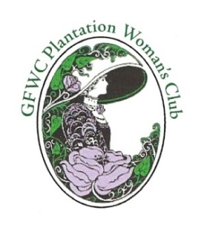
GFWC Plantation Woman's Club, Inc. Annual Woman of the Year Nomination, 2018

PWC Members are eligible for this prestigious award if they have not won previously.

Last year's recipient – JUDY McLEOD

NOMINEE ______________________________________Years in PWC___________

POSITIONS HELD ______________________________________________________

___________________________________________________________________

ACCOMPLISHMENTS/COMMENTS (additional paper may be used)

______________________________________________________________________________________

___________________________________________________________________

___________________________________________________________________

___________________________________________________________________

___________________________________________________________________

___________________________________________________________________

______________________________________________________________________________________

______________________________________________________________________________________

As this is a Club award, please fill out the form with Club accomplishments for 2017 only
for any one club member that you feel deserving of this award.
The current President and all previous winners (listed on page 35 in Yearbook) are ineligible.

GIVE or MAIL to last year's recipient: JUDY McLEOD, P.O. Box 16845, Plantation, FL 33318

_

__________________________________________
Signature of Nominator

Deadline for submitting application is Feb 28, 2018.
From the nominations received, the winner will be announced at the March 13th meeting.
Previous Woman of the Year recipients will meet and choose our 2018 Woman of the Year.

The LUNCHEON will be held on APRIL 7, 2018 - 11:00 am - at JACARANDA COUNTRY CLUB
:gim

