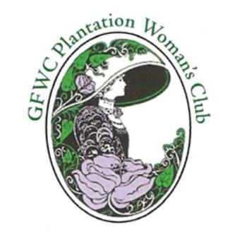
GFWC Plantation Woman’s Club
PO Box 16845,
Plantation, FL 33318-6845
“Giving back to our Community since 1949”
http://www.gfwcplantationwomansclub.com

2022 MEMBERSHIP APPLICATION

The GFWC Plantation Woman's Club is a civic-oriented service organization affiliated
with the Florida Federation of Women's Clubs and General Federation of Women's Clubs.

Our purpose is to foster the spirit of friendly good will among the women of Plantation and to benefit
our community through education, scholarships and community improvement.

Date___________

FIRST NAME LAST NAME PARTNER/SPOUSE

STREET ADDRESS / APT # CITY ZIP

_________
HOME PHONE CELL WORK

EMAIL BIRTHDAY (Month / Day only) HOME STATE

___________________________________________________________________________________________________________
SPONSOR

___________________________________________________________________________________________________________
INVITED BY OR How did you learn about our Club? Prospective members must attend two Club activities before their Membership Application will be reviewed by the Board.

Each year members participate in one or more of the following Club activities listed below. We hope you will volunteer to help and join with others -
- A Community Service Project/Standing Committee
- A Ways and Means Project
- A Monthly Luncheon Committee

Your special skills, abilities and organizational experiences: | Please continue on reverse -
Please indicate your preference for the newsletter: via e-mail______________ via postal mail_______________

Please email your PHOTO for the Yearbook to Gloria Merritt – rgzmoki@aol.com

DUES: Paid with application - $____________________ Date accepted:______________________
New member: Jan-Dec $55 ($40 + $15 Initiation Fee) July-Dec $35 ($20+$15)
Payable to: GFWC Plantation Woman’s Club

Please send Application and Check to: Membership Chair Helen Ackerman
PO BOX 16845, Plantation, FL 33318
954-581-4533 for more information

